System Requirements
Component | Minimum Requirement
OS | Windows 10 (64-bit) or later
RAM | 4 GB
Disk Space | 500 MB free
Display | 1024 × 768 or higher
Internet | Required for cloud backups only

Step 1: Download the Installer
- Open your browser and go to the official releases page:
https://github.com/kotresh75/College-Project/releases/latest
- Under Assets, click on GPTK Library Manager Setup.exe to download.
- Save the file to a convenient location (e.g., Desktop or Downloads folder).
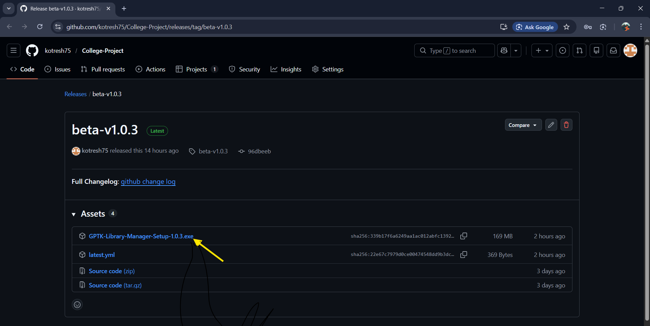
Step 2: Run the Installer
- Double-click the downloaded GPTK Library Manager Setup 1.0.2.exe file.
- If Windows SmartScreen appears, click "More info" → "Run anyway".
Note: This warning appears because the app is not yet signed with a paid Microsoft certificate. It is safe to install.
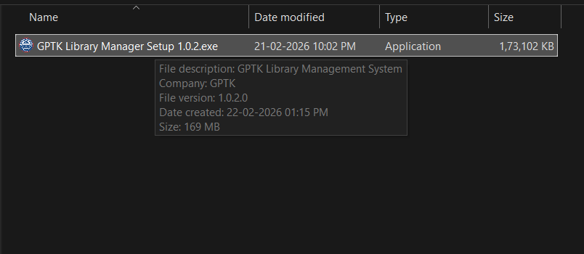
Step 3: Welcome Page
- The installer welcome screen will appear with the GPTK branding.
- Read the information and click "Next" to proceed.
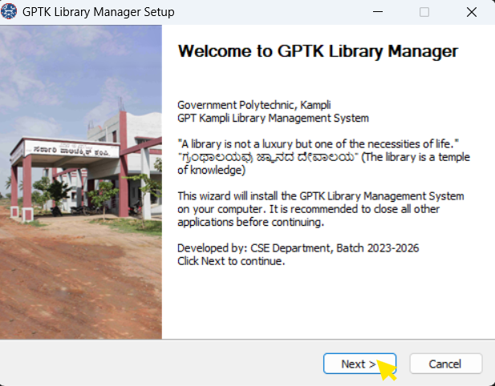
Step 4: Choose Installation Options
- Select who the application should be installed for:
  - Anyone who uses this computer (all users) — Requires administrator privileges. Recommended for shared lab/library PCs.
  - Only for me — Installs for the current Windows user only.
- Click "Next" to continue.
Recommended: Choose "Anyone who uses this computer" for library/lab environments so all staff members can access the application.
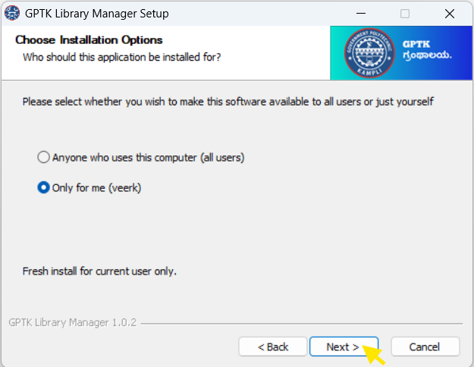
Step 5: Choose Installation Location
- The default installation path will be shown:
  - All Users: C:\Program Files\GPTK Library Manager
  - Current User: C:\Users\<YourName>\AppData\Local\Programs\GPTK Library Manager
- You can click "Browse" to change the location, or leave the default.
- Click "Install" to begin installation.
Tip: It is recommended to keep the default installation path unless you have a specific reason to change it.
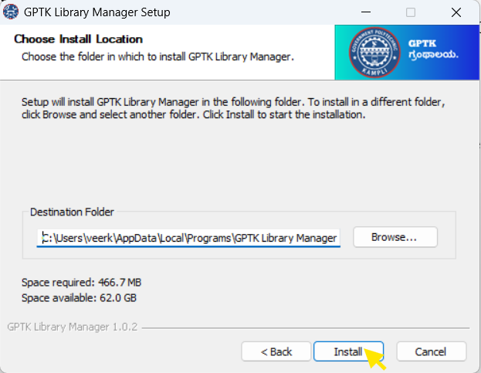

Step 6: Installing
- The installer will now extract and copy all application files.
- A progress bar will show the installation status.
- Do not close the installer or shut down your computer during this process.
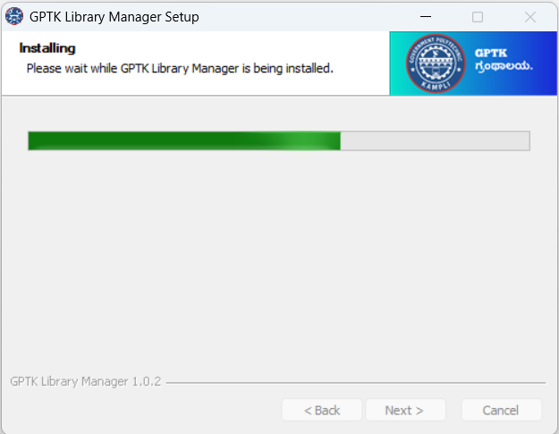
Step 7: Installation Complete
- Once the installation is complete, the finish page will appear.
- Check "Run GPTK Library Manager" if you want to launch the app immediately.
- Click "Finish" to close the installer.
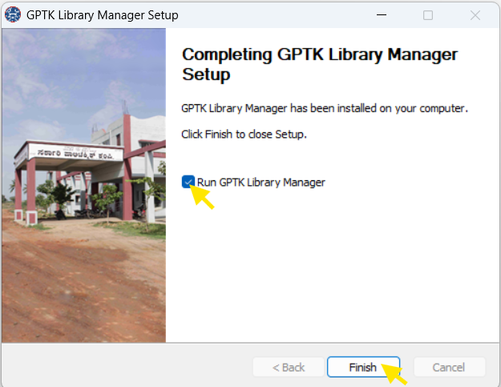

Step 8: First-Time Setup
When you launch the app for the first time, you will be guided through the initial setup:
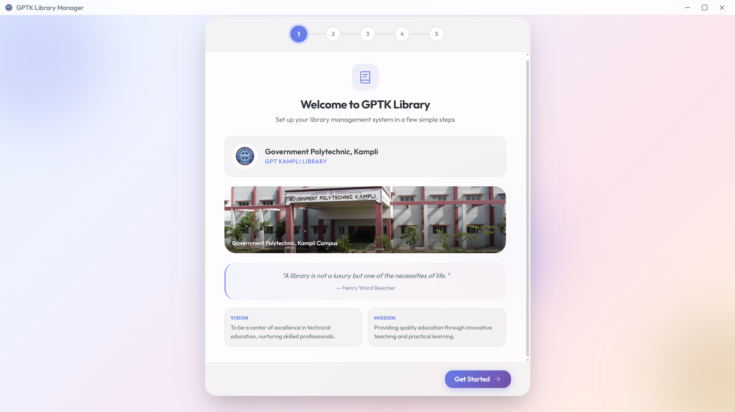
8.1 Admin Account Creation
- Enter the Admin Username (e.g., admin).
- Enter a strong password (minimum 6 characters).
- Confirm the password.
- Click "Create Admin Account".
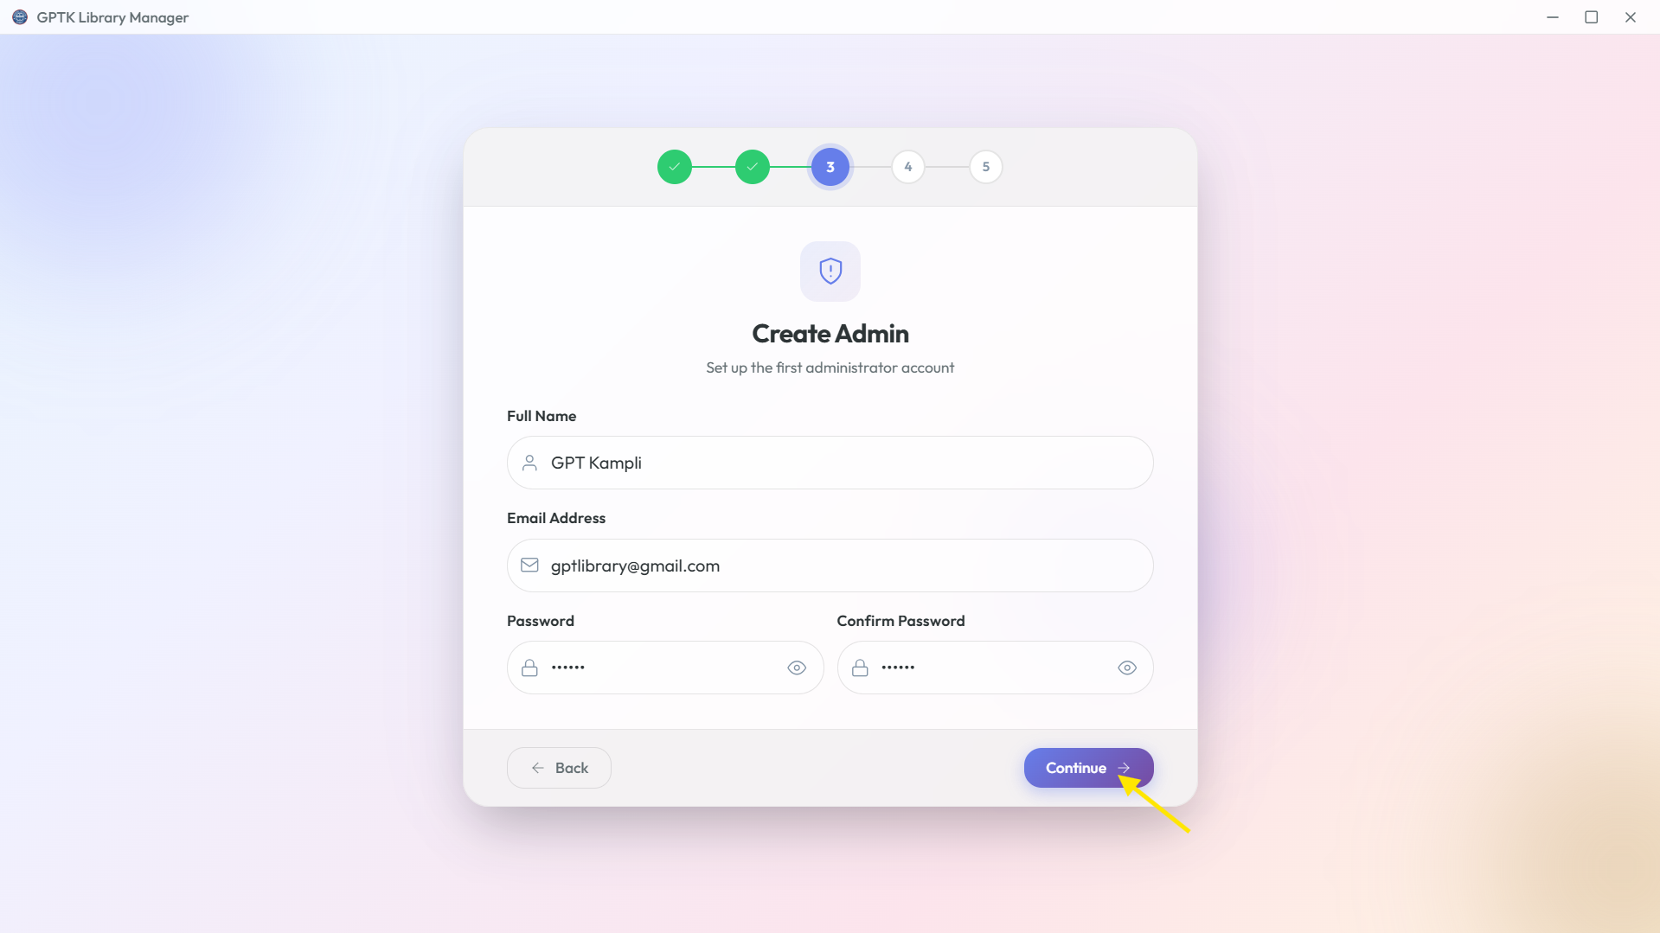
8.2 Library Configuration
- Enter your Library Name (e.g., "GPT Kampli Library").
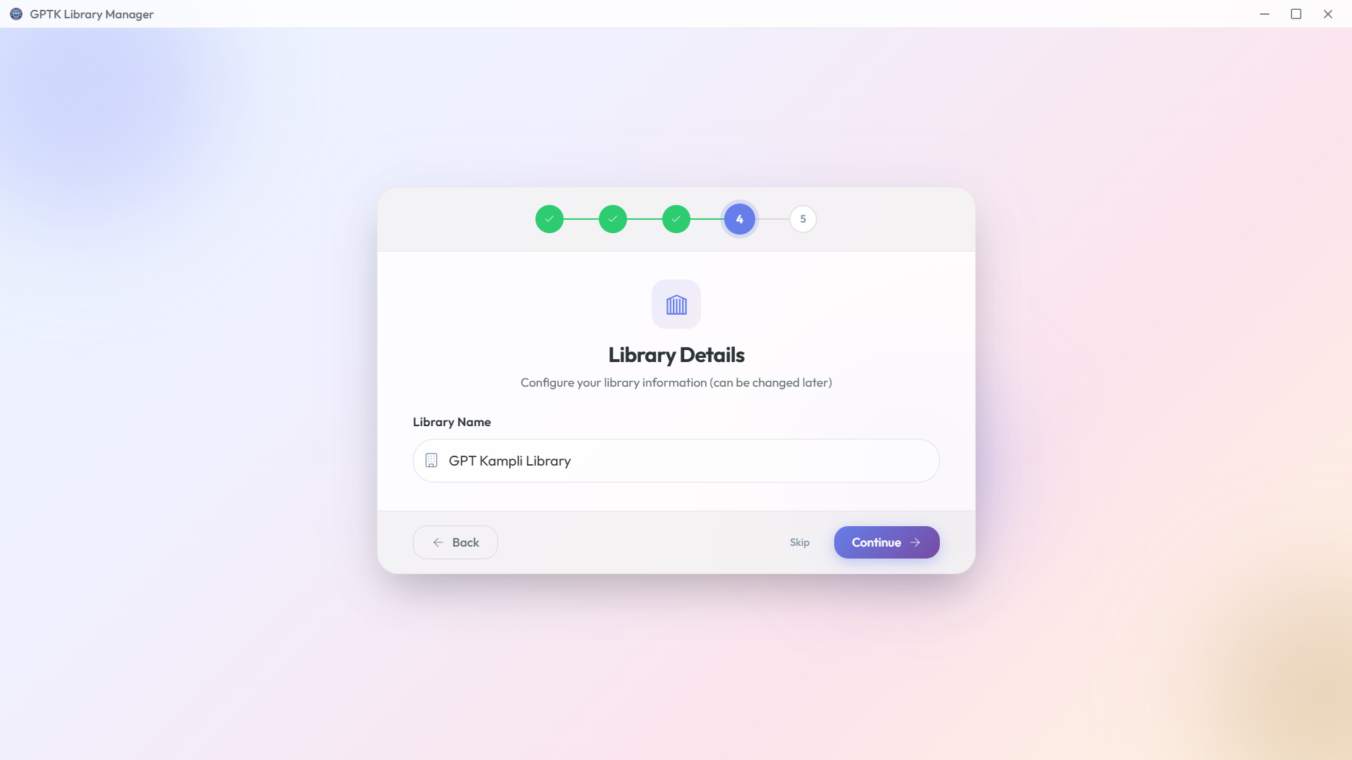
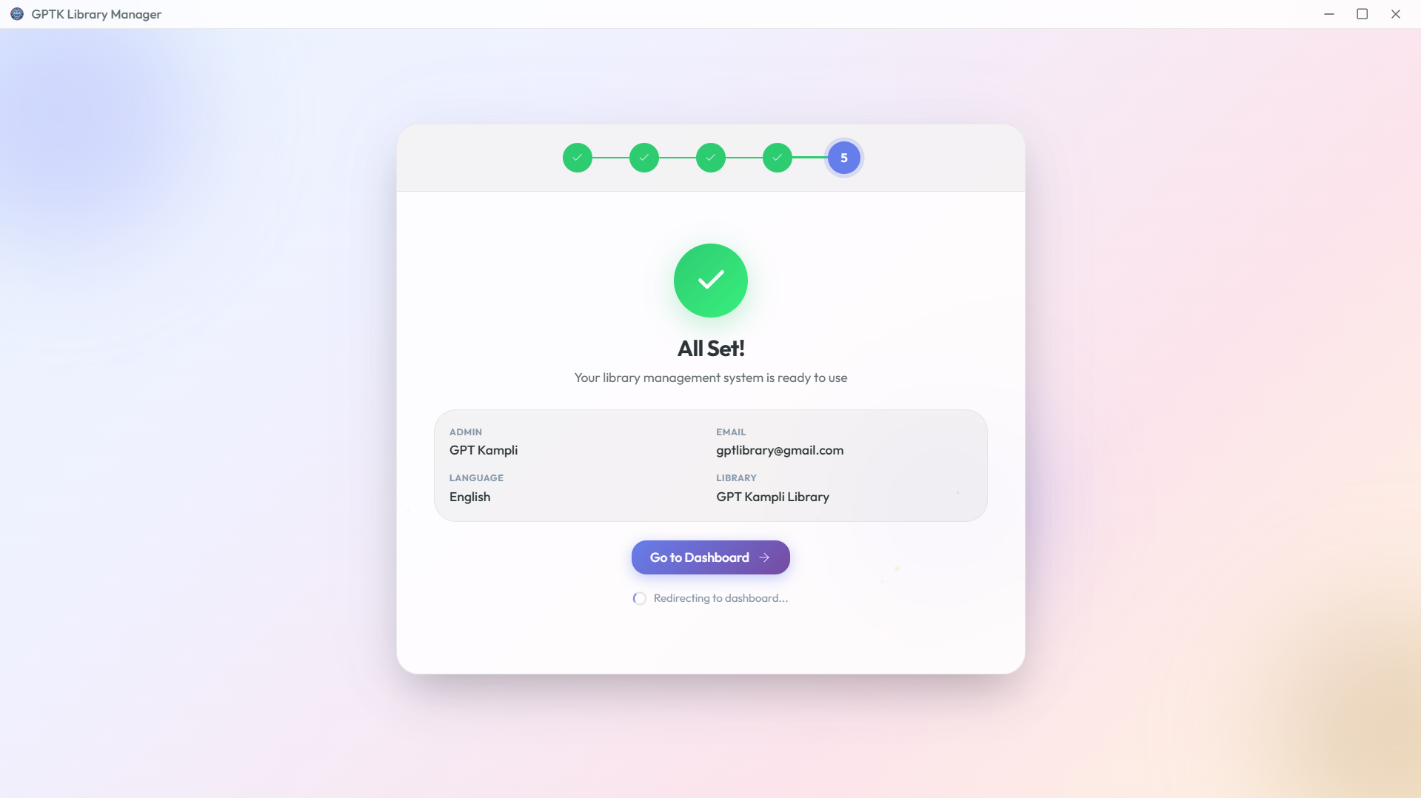
Shortcuts Created
After installation, the following shortcuts are created:
Shortcut Location | Name
Desktop | GPTK Library Manager

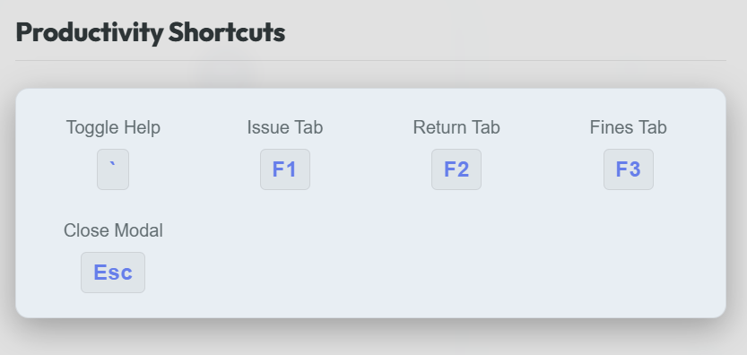
Troubleshooting
Issue | Solution
SmartScreen blocks the installer | Click "More info" → "Run anyway"
"Another instance is running" error | Close the existing GPTK Library Manager window and try again
Installation fails midway | Restart your computer and run the installer again
App doesn't launch after install | Check the Desktop shortcut, or find it in the Start Menu
Database connection error on first launch | Wait a few seconds — the backend server needs time to start
For more help, visit the System Health page in the app and click "Report Bug on GitHub".

